**Plant Systematics**

**Task 1**

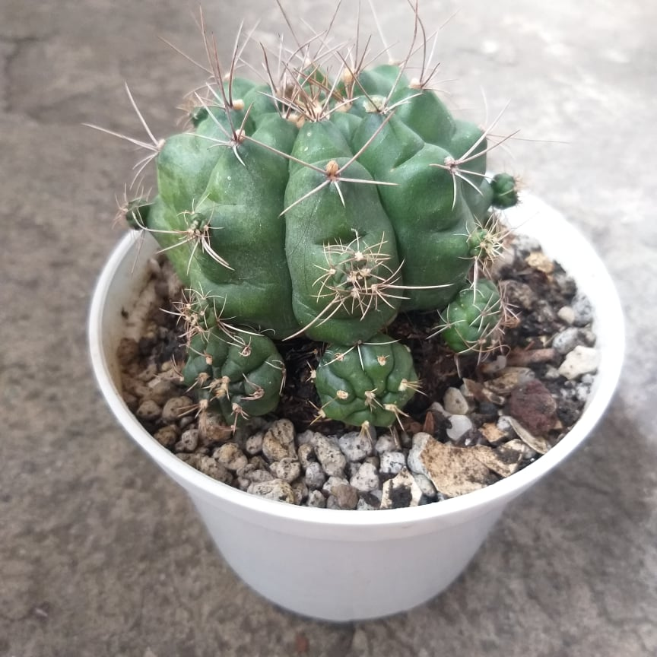

**Common Name:** Cactus

**Scientific Name:** *Gymnocalycium baldianum*

**Kingdom:** Plantae

**Class:** Magnoliopsida

**Order:** Caryophyllales

**Family:** Cactaceae Juss. – cactus, cacti

**Genus:** *Gymnocalycium*

**Species:** *Gymnocalycium baldianum*

**Key D - cacti:** One genus and family **[CACTACEAE]**

It is a globose cactus, spherical or a little flat, with a diameter up to 8 cm, dark green in color, or sometimes brown. It has 8 to 10 ribs with tubercle-shaped areolas, covered in groups of 6 to 8 pale gray, curved spines, giving to the species its common name of spider-cactus.

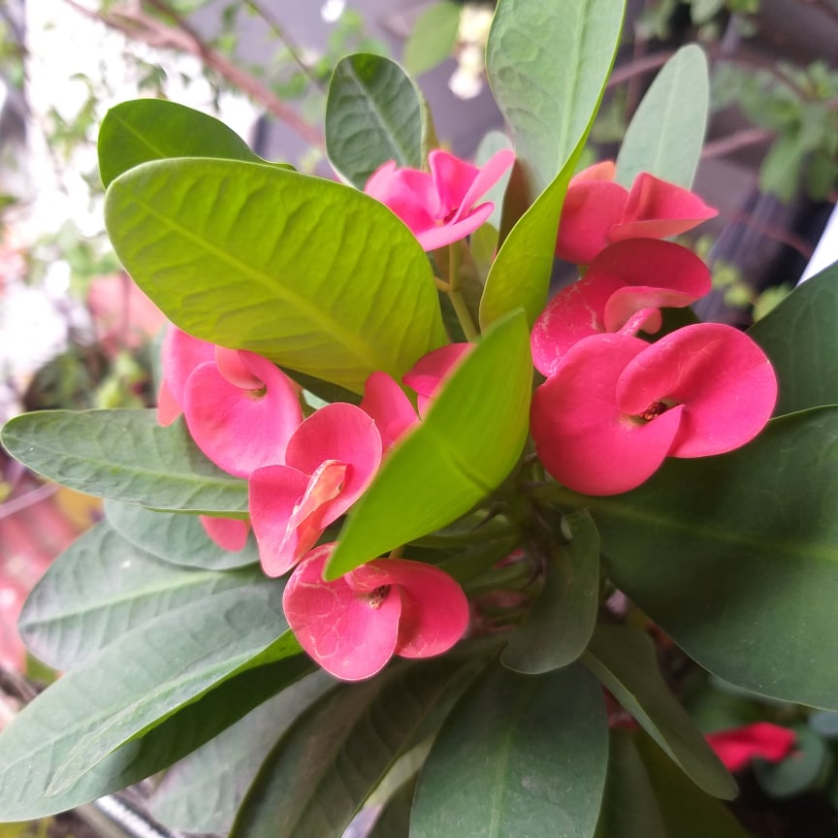

**Common Name:** Crown of Thorns

**Scientific Name:** *Euphorbia milii*

**Kingdom:** Plantae

**Phylum:** Spermatophyta

**Class:** Dicotyledonae

**Order:** Euphorbiales

**Family:** Euphorbiaceae

**Genus:** *Euphorbia*

**Species:** *Euphorbia milii*

**Key G2 – woody plants with alternate, simple, palmately lobed leaves:** 7 Leaf (lobe) margins entire **[EUPHORBIACEAE]**

Crown of Thorns is a deciduous, herbaceous, perennial shrub with bright green leaves and greenish flowers. The flowers are enclosed within long-lasting and bright bracts of red or yellow. The plant is loose in form, spiny and irregularly shaped, with thick, black spines and its historic presence in the Middle East led to the belief by some that the stems of this plant had been used in Christ's crown of thorns, hence the common name.

**Common Name:** Bougainvillea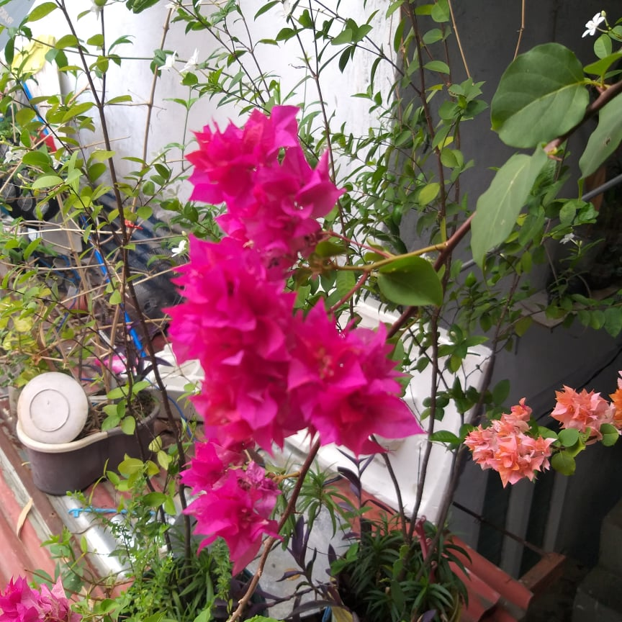

**Scientific Name:** *Bougainvillea spectabilis*

**Kingdom:** Plantae

**Phylum:** Spermatophyta

**Class:** Dicotyledonae

**Order:** Caryophyllales

**Family:** Nyctaginaceae

**Genus:** *Bougainvillea*

**Species:** *Bougainvillea spectabilis*

Bougainvillea spectabilis is an aggressive climbing vine or shrub growing >10 m high. Native to Brazil, this species has been extensively introduced into tropical, subtropical and warm temperate regions of the world.

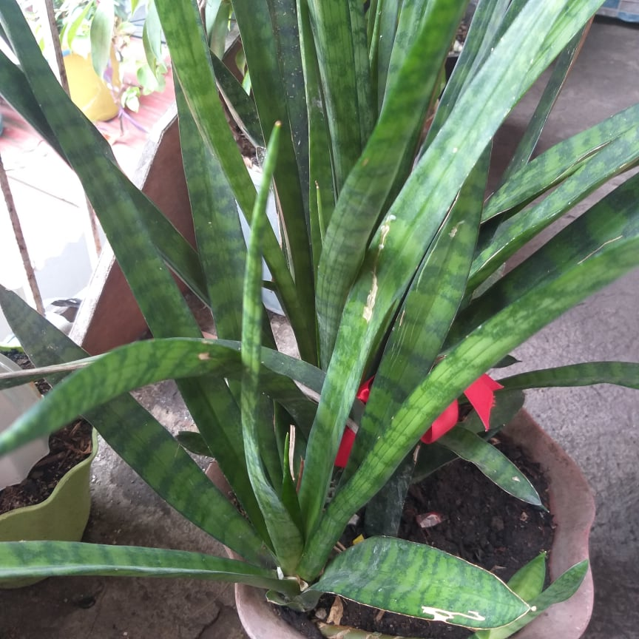

**Common Name:** Snake Plant

**Scientific Name:** *Dracaena trifasciata*

**Kingdom:** Plantae

**Class:** Dicotyledonae

**Order:** Asparagales

**Family:** Ruscaceae

**Genus:** *Dracaena*

**Species: *Dracaena trifasciata***

**Key M2 – monocots with broad leaves:** Stem simple (never branched); inflorescence a terminal raceme or panicle (Maianthemum) or axillary racemes or clusters of 1-9 flowers (Polygonatum); fruit a berry **[RUSCACEAE]**

Dracaena trifasciata, or snake plant, is an evergreen ornamental houseplant with long sword-like variegated green and yellow leaves. The Dracaena trifasciata is extremely easy to grow at home and requires little care. In fact, the snake plant is so hardy that it almost thrives on neglect.

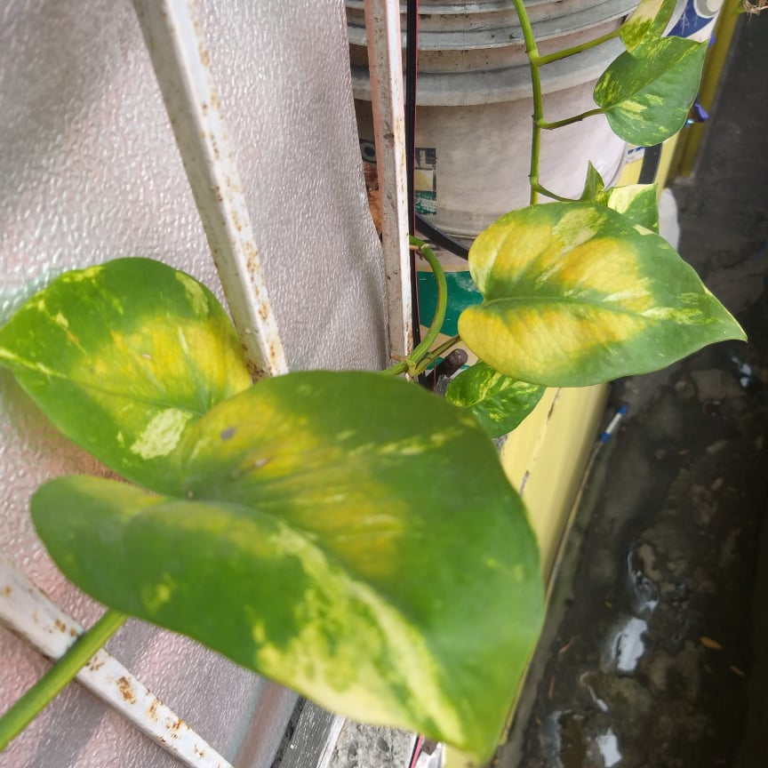

**Common Name:** Snake Plant

**Scientific Name:** *Epipremnum aureum*

**Kingdom:** Plantae

**Class:** Dicotyledonae

**Order:** Alismatales

**Family:** Araceae

**Genus:** Epipremnum

**Species:** *Epipremnum aureum*

**Key C3 – rooted aquatics with basal and simple, broad leaves:** Leaves obovate, cuneate at the base, sessile, pale green; plants floating because of “unwettable” leaf surfaces **[ARACEAE]**

Pothos is a low maintenance perennial evergreen houseplant in the Araceae family. Desired for its glossy, green or variegated leaves on cascading stems. It only grows 6 to 8 feet as a horizontal groundcover, but the trailing, climbing vines can grow as long as 40 feet. This feature makes it well-suited for hanging baskets.

**Task 2**

|  | ***Gymnocalycium baldianum (Cactus)*** | ***Euphorbia milii***  **(Crown of Thorns)** | ***Bougainvillea spectabilis* (Bougainvillea)** | ***Dracaena trifasciata* (Snake Plant)** | ***Epipremnum aureum* (Devil’s Ivy)** |
| --- | --- | --- | --- | --- | --- |
| **Life span** | Perennial | Perennial | Perennial | Perennial | Perennial |
| **Plant thriving** | Can thrive outdoor and indoor | Can thrive outdoor and indoor | Can thrive outdoor and indoor | Can thrive outdoor and indoor | Can thrive outdoor and indoor |
| **Leaf size** | N.A. | 6-10 cm long | 5-10 cm long | 30-90 cm long | Indoor leaves - 10 cm long  Outdoor leaves - up to 76 cm long |
| **Leaf complexity** | N.A. | Simple | Simple | Simple | Simple |
| **Leaf or leaflet toothing** | N.A. | Entire | Entire | Entire | Entire |
| **Leaf or leaflet lobing** | N.A. | Not lobed | Not lobed | Not Lobed | Not lobed |
| **Leaf or leaflet arrangement** | N.A. | Spiral | Alternate | Cluster | Alternate |
| **Leaf disposition** | N.A. | Cauline | Cauline | Basal | Cauline |
| **Leaf venation** | N.A. | Pinnate | Pinnate | Parallel | Pinnate |
| **Propagation** | Cutting | Cutting | Cutting | Cutting | Cutting |

**Character A:** Plant is perennial and thrive in both indoor and outdoor (+), Plants is not perennial and thrive indoor only or outdoor only (-).

**Character B:** Leaves are complex and lack toothing (+), Leaves lack complexity and have an entire toothing (-).

**Character C**: Leaves are lobed and lack pinnate venation (+), leaves are unlobed and have pinnate venation (-).

**Character D:** Leaves are arranged in alternate and grow above the ground stem (+), Leaves are not arranged in alternate and grow lower on the stem (-).

**Character E:** Plant propagation is through cutting (+), Plant propagation is not through cutting (-).

| **Characteristics** | ***Gymnocalycium baldianum (Cactus)*** | ***Euphorbia milii***  **(Crown of Thorns)** | ***Bougainvillea spectabilis* (Bougainvillea)** | ***Dracaena trifasciata* (Snake Plant)** | ***Epipremnum aureum* (Devil’s Ivy)** |
| --- | --- | --- | --- | --- | --- |
| **A** | + | + | + | + | + |
| **B** | N/A | - | - | - | - |
| **C** | N/A | - | - | - | - |
| **D** | N/A | - | + | - | + |
| **E** | + | + | + | + | + |

**Task 3**

